FDA and USDA Actions
- You are the local inspector at a USDA plant. The plant EST number is EST 5516. You have discovered the attached label in your plant. After consulting with the Labeling and Program Development Staff and based on a prior ruling from that team it has been decided that you will write an NR for this product. Please complete the attached NR form using the pictures below to describe the product and labeling issues. (25 points)
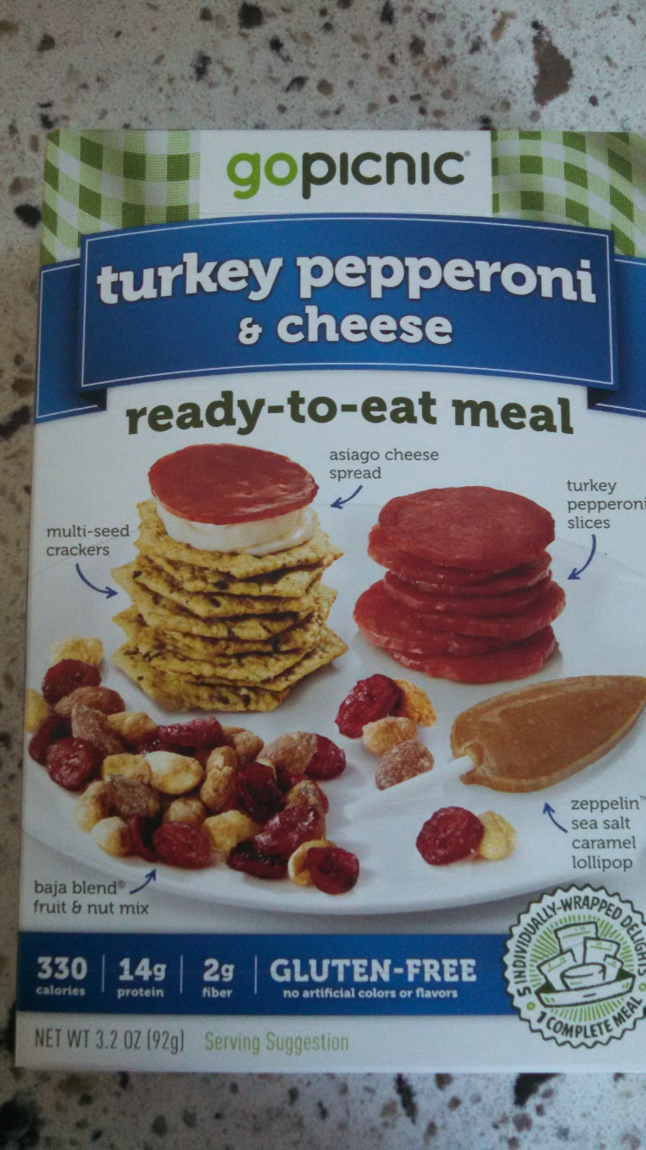
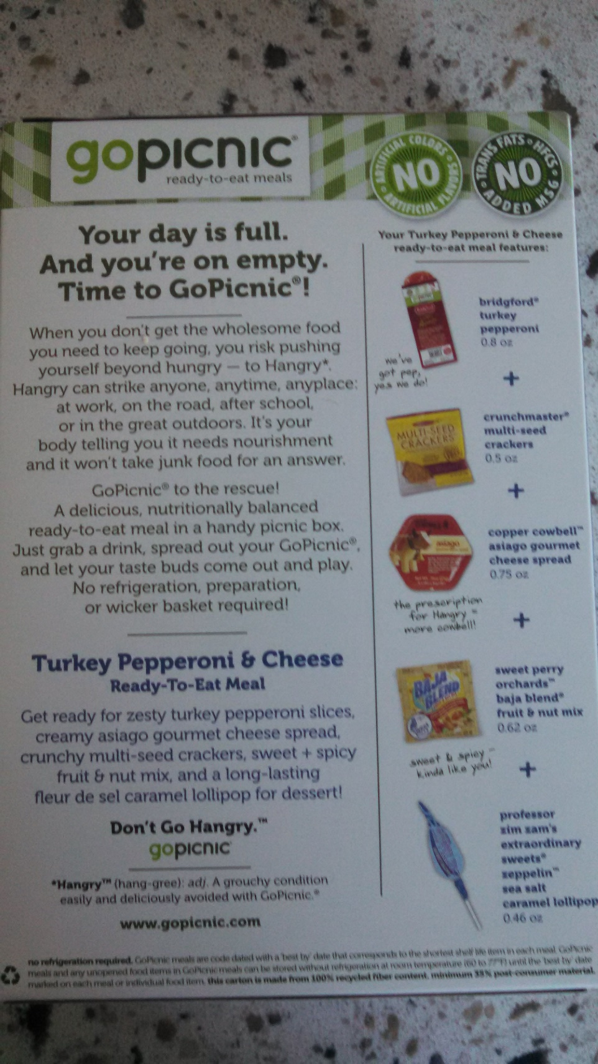
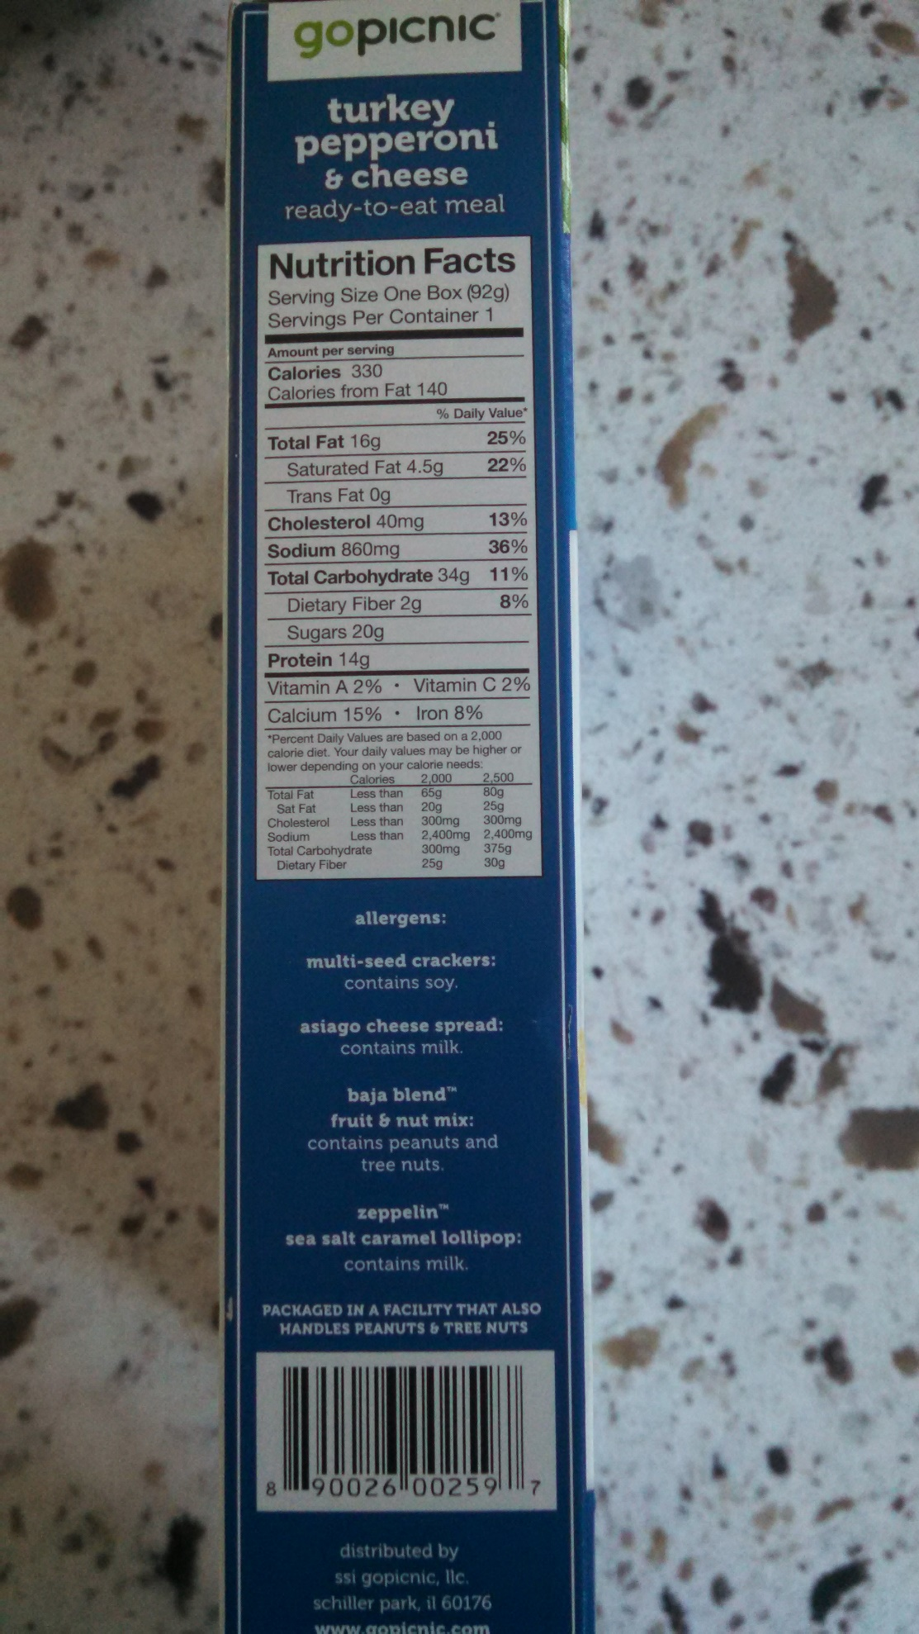
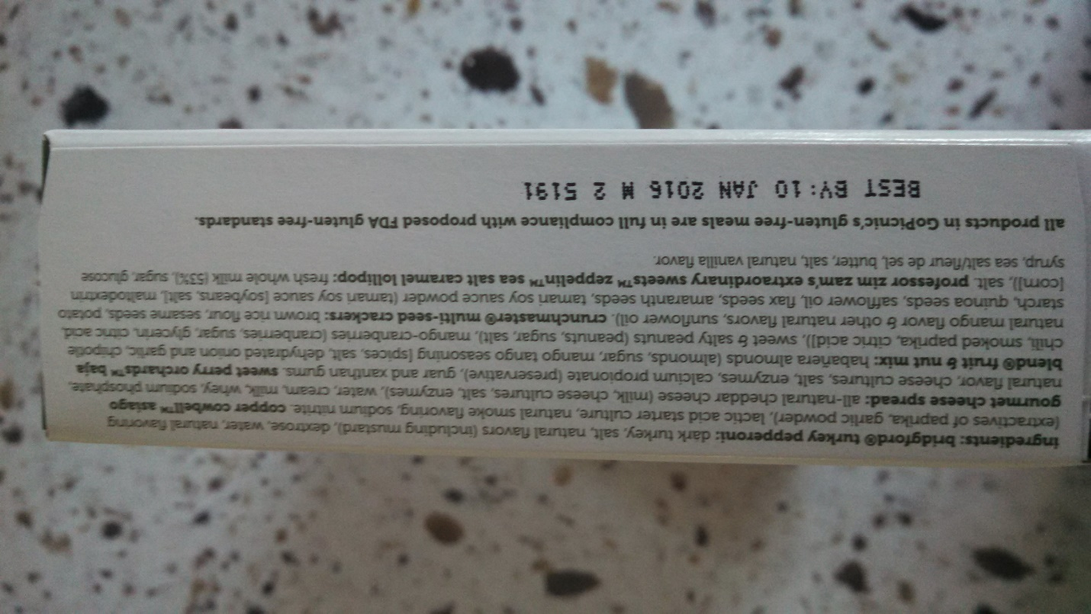
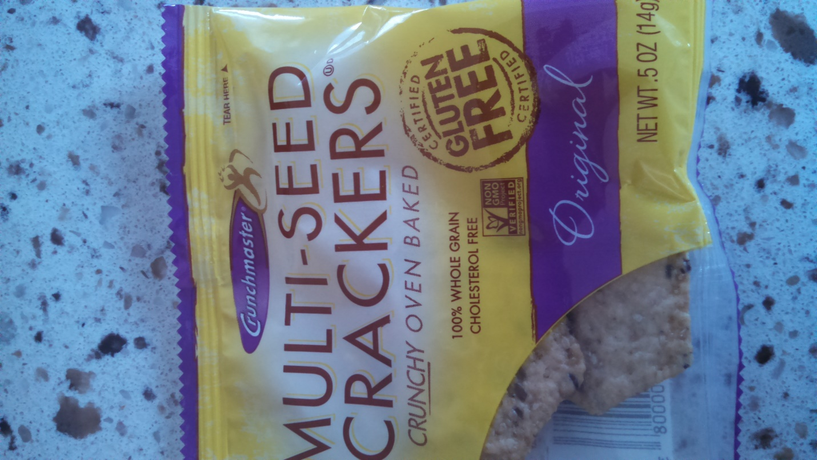
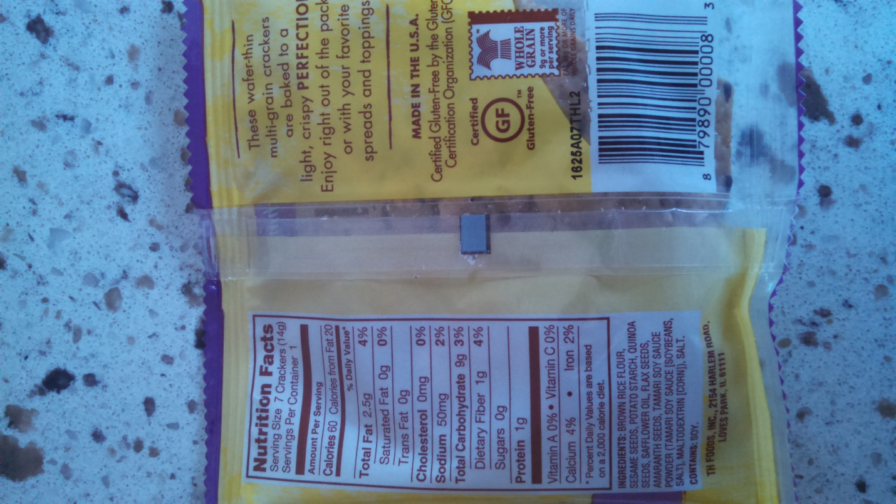
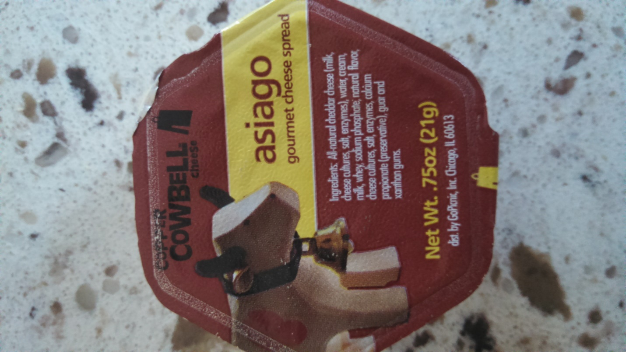
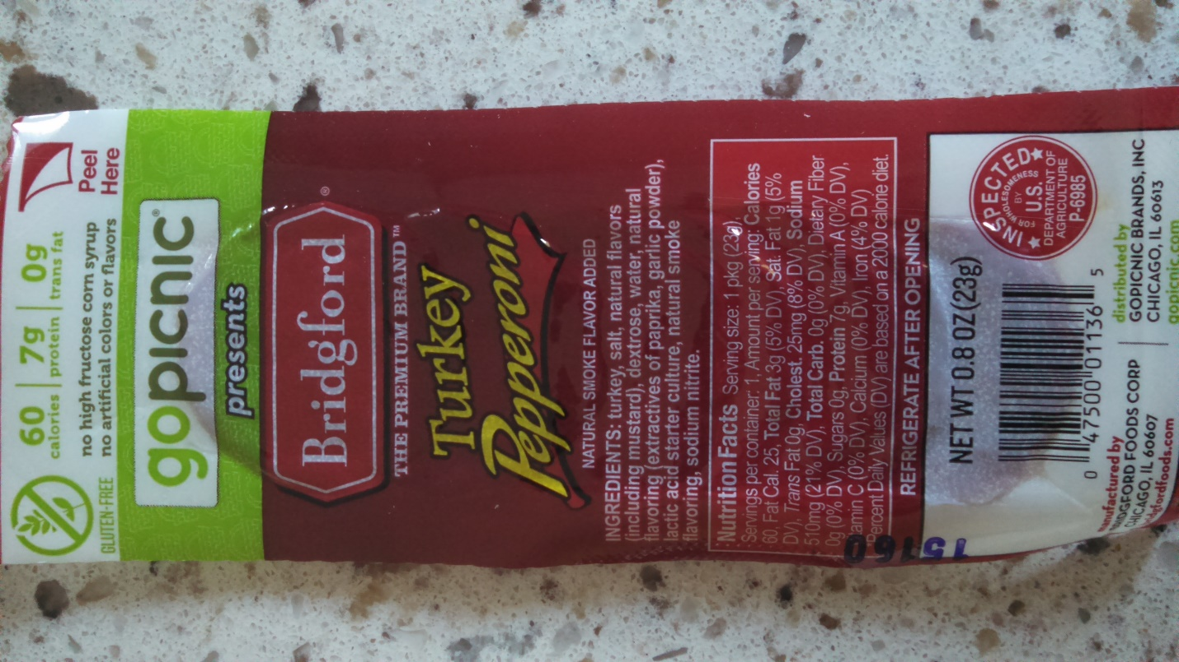
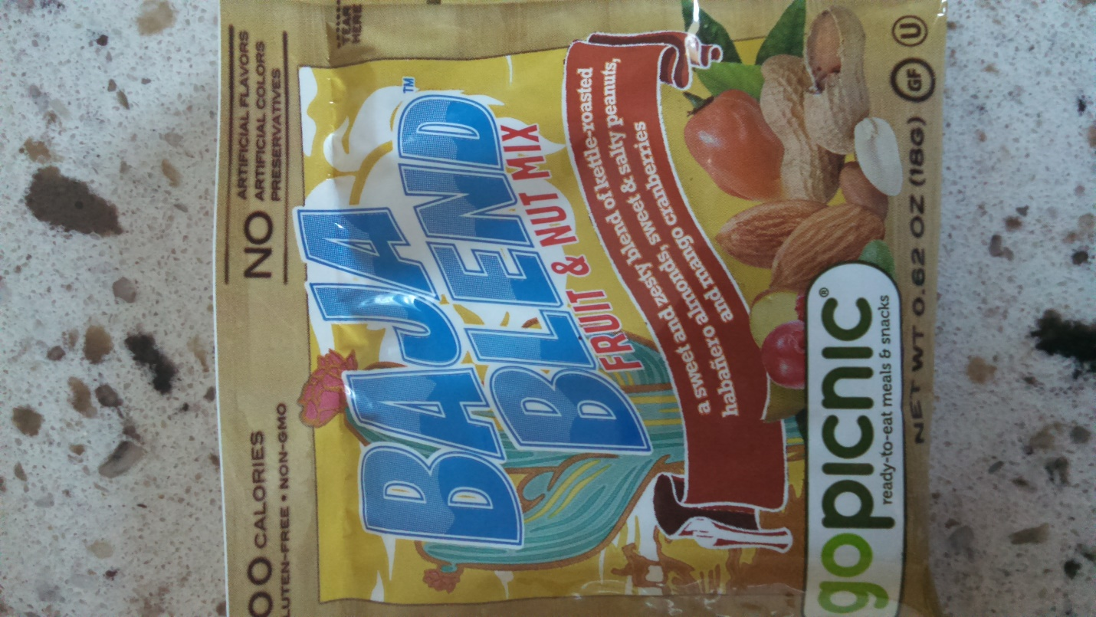
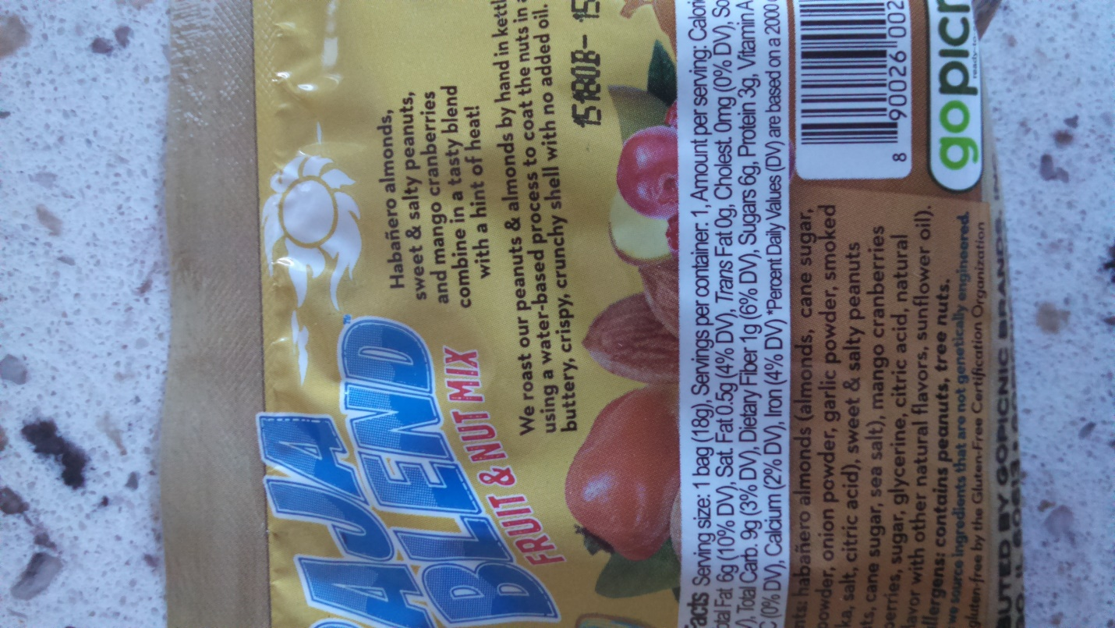
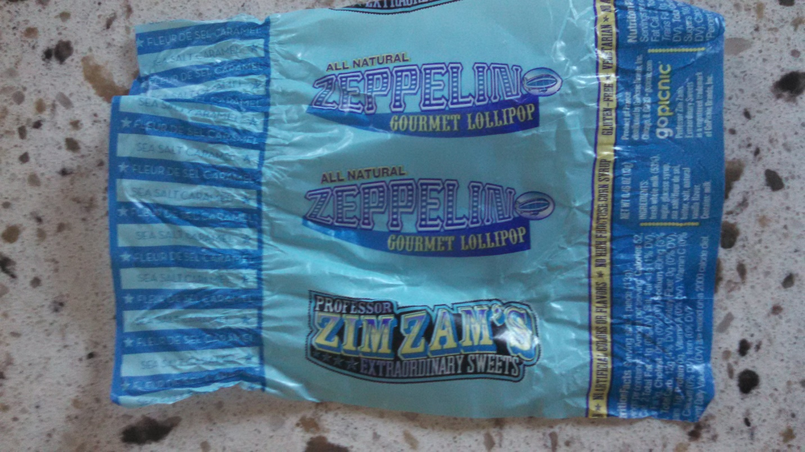

- The company you are working for has just received the attached FDA warning letter. Please write a response to the FDA for your company. (25 points)
https://web.archive.org/web/20150213034802/http://www.fda.gov/ICECI/EnforcementActions/WarningLetters/2014/ucm418768.htm

